

**BASIC COMPUTER PROGRAMMING**

**DEE 4113**

**LAB MODULE 2**

**STUDENT NAME: Ho Weng Yin**

**STUDENT ID: 1125240324610**

**PROGRAMME: Diploma in Electrical Electronics Engineering (ODL)**

**SEMESTER: Year 1 Semester 1**



**FACULTY OF ENGINEERING**

**EXPERIMENT 2 (C3, PLO2):**

**SELECTION STRUCTURES IN C PROGRAMMING**

* 1. **Objectives**

1. To construct *if* selection statement in the C programming.

**2.0 Equipment List**

Personal Computer with Microsoft Visual C++

**3.0 Procedure**

1. By using selection structure **if-else**, write a program to ask the user to enter a password.
2. By using an ***if*** statement, design a C program that asks the user to input integer number between 1 and 5. After the user has input the number, the program will display whether the number is equal one or not. Determine what is printed next if the user enter the numbers as below :
3. 1
4. 2
5. 3
6. 4
7. 5

**4.0 Results**

Screenshot of the result

**Program 1**

Scenario 1

|  |
| --- |
| #include <stdio.h>  #include <string.h>  int main() {  // Predefined password  char correct_password[] = "securepassword";  // Buffer to store user input  char user_password[50];  // Ask the user to enter a password  printf("Please enter your password: ");  // Read user input safely using fgets  if (fgets(user_password, sizeof(user_password), stdin) != NULL) {  // Remove the newline character if present  size_t len = strlen(user_password);  if (len > 0 && user_password[len - 1] == '\n') {  user_password[len - 1] = '\0';  }  // Check if the entered password matches the predefined password  if (strcmp(user_password, correct_password) == 0) {  printf("Access granted.\n");  }  else {  printf("Access denied. Incorrect password.\n");  }  }  else {  printf("Error reading input.\n");  }  return 0;  } |

Scenario 2

**Program 2**

Source Code

|  |
| --- |
| #include <stdio.h>  int main() {  int number;  // Ask the user to input an integer between 1 and 5  printf("Please enter an integer between 1 and 5: ");  scanf_s("%d", &number);  // Check if the number is between 1 and 5  if (number >= 1 && number <= 5) {  // Check if the number is equal to one  if (number == 1) {  printf("The number is equal to one.\n");  }  else {  printf("The number is not equal to one.\n");  }  }  else {  printf("The number is out of range.\n");  }  return 0;  } |

Scenario 1

When not equal 1

Scenario 2

Equal to 1

Scenario 3 the input is out of 5

**4.1 Procedure 1:**

Flowchart of the program

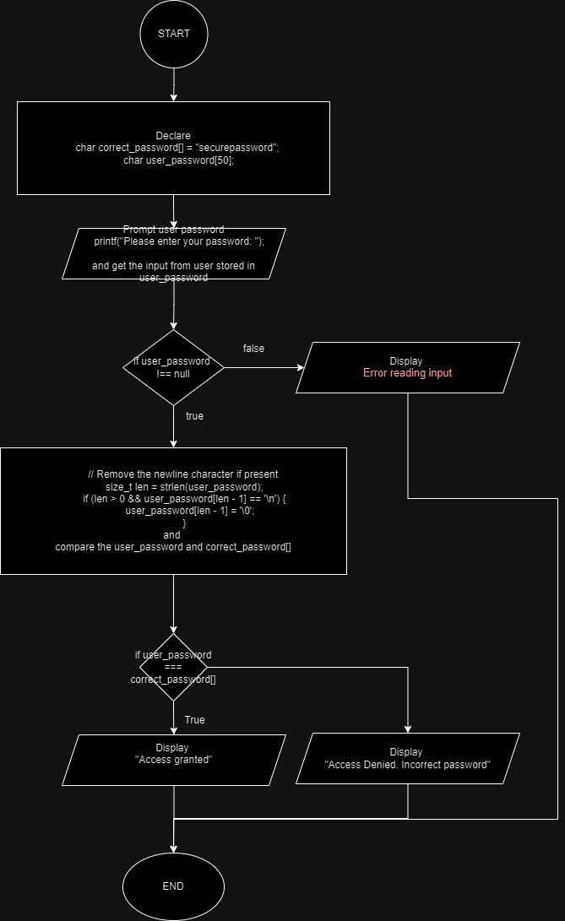

**4.2 Procedure 2**

Flowchart of the program

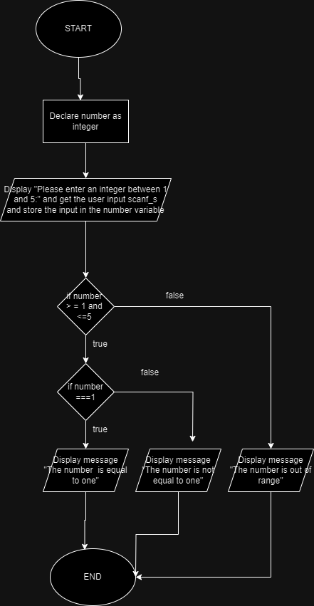

**5.0 Conclusion**

These two programs are using if-else statement, for the first use the strcmp to compare the correct password and user password, if true then the access granted else the access denied. For the second program, it is getting user input then check the input whether within the range >=1 and <=5 as well as the check whether it is equal one or not.